Lunch@Work Reimagined

Maksood Mohiuddin

Problem Space, Need Finding, Brainstorming, Low Fidelity Prototypes, Surveys and Evaluation

Georgia Institute of Technology

1  INTRODUCTION

My Business plan is to re-imagine the lunch ordering task while at work. The context is most people might like to eat lunch at their workplace in the breakroom or in their desk without leaving the workplace using seamless multi-channel interaction pattern for ordering to save time and reduce logistical burden.

2 PROBLEM SPACE

Problem space is in work environment most people have limited time for lunch break and lot of time does not get the chance to leave workplace to get lunch. Typical options for lunch at work are nearby restaurants or cafeteria at work. My target domain is giving another option for lunch at work using easy multi-channel ordering process via text message/voice/web/app as interaction pattern. Lunch will be delivered to a common area in the workplace at a preset time from a curated menu from diverse cuisine and an attractive pre-set price.

Within the meal delivery eco systems (e.g. Uber Eats), this will be an attractive alternative. The differentiating factors I like to design are elimination of individual delivery fee by bulk delivery, lower lunch cost by working with restaurant partners to achieve economy of scale, same preset price every day to avoid surprise and seamless delivery to a common area by working with workplace property management.

3 USER TYPES

I am interested in designing for working professionals in office environment however the design can be targeted for any workplace environment such as retail stores, manufacturing plants, warehouses, educational facilities and public offices. The target demography is any working professional and not all participant might have experience ordering lunch using meal delivery services.

The motivation for the working professional to get engage in the task of lunch ordering at work would be this should help them with being more productive at work by saving time and eliminating the distraction of leaving workplace to get lunch. Other motivating factors would be this will give more lunch option with lower cost and reduce the stress related to everyday lunch logistics.

4 NEEDFINDING PLANS

4.1 Naturalistic Observation Execution

One of the needfinding plan I have executed is naturalistic observation. Naturalistic observation is observing people in their natural context. Simply observing is a great way to understand the users need. I have augmented a survey (section 8 & 9) with my naturalistic observations to reduce the bias I may have with simply naturalistic observations

I have observed the interaction pattern people use for ordering lunch and logistics associated with it. My observation took place at the floor of the office park in Seattle, WA where I currently work with the timeframe of late morning (11 AM) to late afternoon (2 PM) on a weekday, during the week of September 11-15. My floor has about 100 workers, so that was my sample data set. I have observed that roughly about 25 people ate at their desk, 35 at common breakroom, 20 work cafeterias and 20 leave the office park to get lunch. Out of people the 60 people who ate at their desk or common work area, 40 people brown bag their lunch from home, 20 people ordered lunch via meal delivery services, mainly Peachd and Uber Eats. I have also observed that people ate variety of of cuisine (e.g. sandwiched, salads, pasta, vegetarian, gluten free).

4.2 Participant Observation Execution Augmented with Preliminary Analysis of Existing User Interfaces

In participant observation, we participate in the task by ourselves to understand the users need. I have followed a lunch ordering routine at my work by ordering lunch using different options available at my work office park. My plan was to understand which option gives me the greater flexibility in terms of ease of ordering, less logistical burden, offer more variety and cost/value ratio. Along the way, I have also conducted a preliminary analysis of existing user interfaces as I have interacted with different services. I have gathered both qualitative (cuisine options and logistic) and quantitative (time and money) data.

**4.2.1 Work Cafeteria**

I have found that lunch queue at work cafeteria is reasonable. However, cuisine options were limited and repetitive. Logistically on average it took about 45 minutes to eat lunch at cafeteria. Price pointwise ($10 average) were poor value for the money considering quality. The ordering interface were typical point of sale interaction patterns.

**4.2.2 Restaurants**

Going out to eat gave me more cuisine options but most places had relatively longer queue time than work cafeteria during lunch hours. Logistically the process took more than an hour because of either walking or driving involve. Price pointwise ($15 average) it was in the higher side because of high standard deviation of prices in different restaurants. The ordering interface were diverse with point of sale, server service, online (i.e. chipotle) and mobile pre-order (i.e. Panera bread mobile app) interaction patterns.

**4.2.3 Meal Delivery Services**

This was a twofold participation. I have signed up for a meal delivery service call Peachd which delivered meal at my office common area at a delivery time I have selected. It took me about 30 minutes to eat, and choices were adequate but the price point was unpredictable (varied between $8 to $15). The ordering interface gives the option to order via web or text message and interaction patterns are presented in Figure 1-6.

I ordered via Uber Eats which delivered meal at my office lobby very close to promised estimated delivery time. It took me about 30 minutes to eat lunch but the price point was higher (because of $4 delivery fee), choices were adequate but required to pick up from outside office area in the lobby. The ordering interface were a mobile app and interaction patterns are presented in Figure 7-9.

Participant observation can have recall bias. To reduce that bias, I have recorded by observation very close to the date I have conducted my observation.



Figure 1: Peachd Web User Interface 1



Figure 2: Peachd Web User Interface 2



Figure 3: Peachd Web User Interface 3



Figure 4: Peachd Web User Interface 4

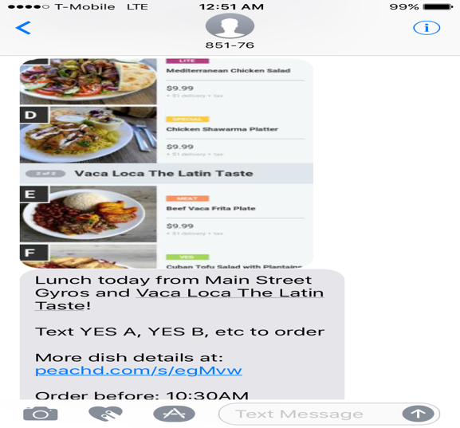

Figure 5: Peachd Text Message User Interface 1

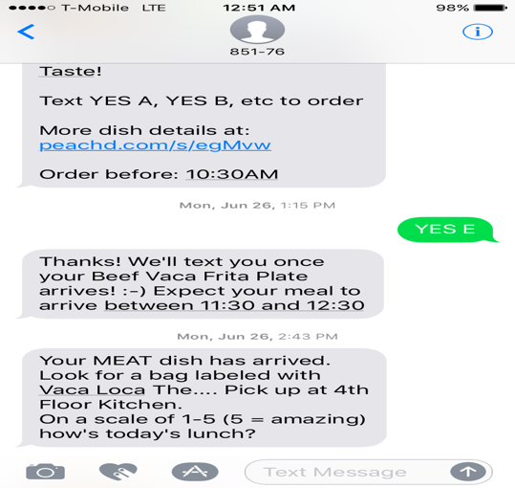

Figure 6: Peachd Text Message User Interface 2

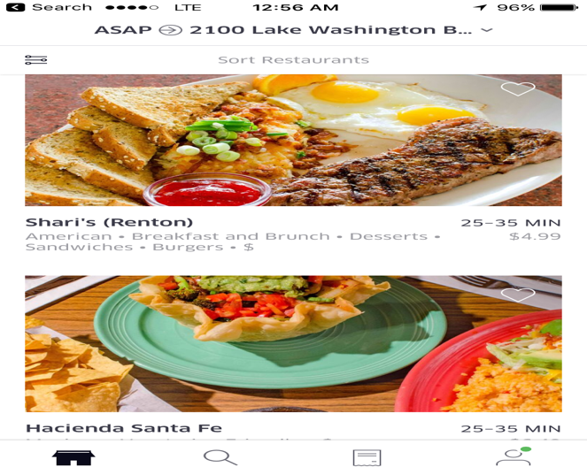

Figure 7: UberEats Mobile App User Interface 1

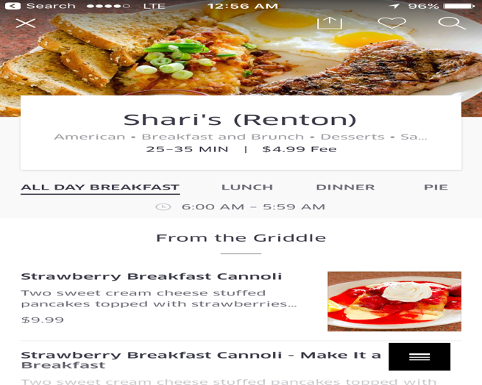

Figure 8: UberEats Mobile App User Interface 2

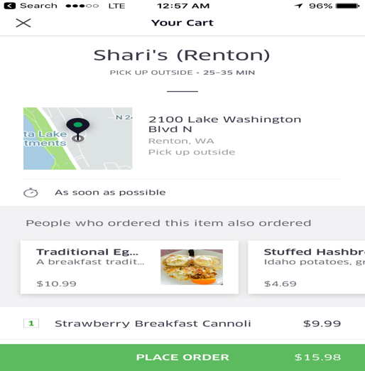

Figure 9: UberEats Mobile App User Interface 3

5  BRAINSTORMING PLAN & EXECUTION

My brainstorming plan will be as follows:

1. Individual brainstorming with total to 30 minutes allocate and free flow form.
2. Two sessions brainstorming totals, 15 minutes each, and a break in between.
3. All ideas will be scribed into one page brainstorming worksheet.
4. Any ideas no matter how far-fetched will be considered.
5. Entire lunch ordering tasks will be in the scope.

I have executed my brainstorming in a one page worksheet (Figure 10). Key takeaways from brainstorming execution as follows:

Core Problem: Easy lunch logistic with set price options is a desirable for many working professionals but there seems to lack of such service in today’s marketplace.

Core Solution: work with local restaurants to be able to provide set price everyday by enabling bulk orders, and from consumer side provide a platform that facilitated order pooling seamlessly

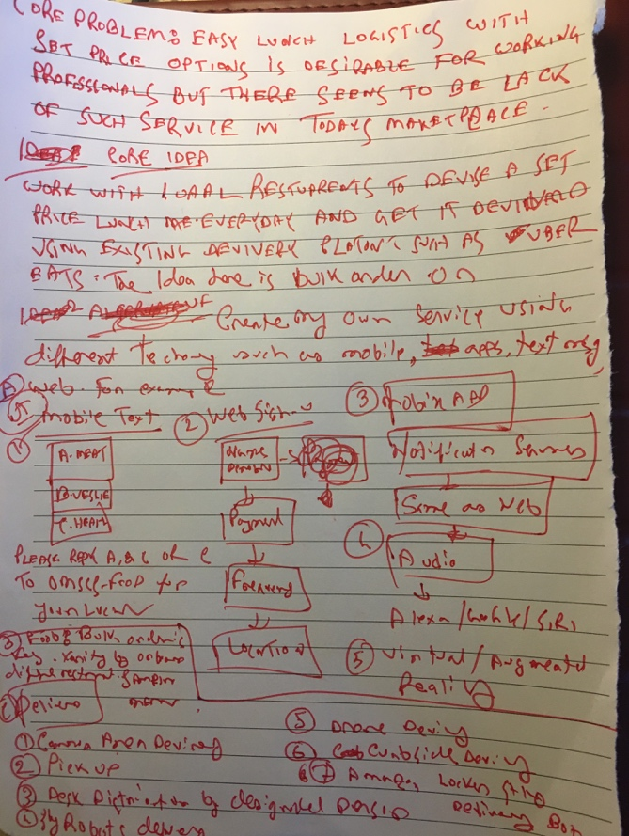

Figure 10: Brainstorming Worksheet

Breakdown of the solution & different alternatives: using divide and conquer strategy:

1. *Platform enablement* using web, mobile web, text messaging, audio interface, virtual/augmented reality
2. Onboard restaurants for incentivizing set price options by encouraging sample menu to build customer base, provide low cost items as menu offering and steady & predictable ordering.
3. *Delivery logistics* ranges from delivering to common area, curbside pickup, desk delivery by a designated person or robots, amazon locker style delivery box, drone delivery

6  PROTOTYPES

Based on the requirement gathering, majority preferred to have a set price lunch that is also affordable, provide an improvement to current lunch logistics, and offer web, native mobile app and voice interaction as platforms, so these three platforms offering are the selection criterion for my prototypes. Since keeping the price low is important, delivery options that will increase price such as drones or robots will not be part of prototypes, and instead common area, curbside pickup, delivery by designated person will be considered. Onboarding restaurant task will not be in the scope of prototype since that is a logistical task instead it will be assumed that that is feasible.

6.1  Web Prototype

My first prototype is a simplistic wireframe for a responsive web page design that will scale appropriately for different screen sizes. Using the web interface user can sign up for the lunch delivery service, setup payment methods, pick a delivery time frame & method to receive the delivery, and select menu option for every day.

**Landing Page:**

|  |  |  |
| --- | --- | --- |
| Logo/Branding |  |  |
| Office Address to Get Started Prompt | **Sign In Link** | **Registration Link** |
| Promotions Materials | | |
| Sample Menu with Food Images | | |
| How It Works | | |
| Mobile App Links | | |
| Legal/About/FAQs | | |

**Sign in Page / Update Account Page:**

|  |  |
| --- | --- |
| Logo/Branding |  |
| User Name | **Text Prompt** |
| Password | **Text Prompt** |
| 2 Factor Auth Option Link | **Submit Button** |

**Menu Selection Page:**

|  |  |
| --- | --- |
| Logo/Branding |  |
| Date | **Time (auto selected based on preference)** |
| Meat Option | **Image** |
| Vegetarian Option | **Image** |
| Light/Healthy Option | **Image** |
|  | **Submit Button** |

**Profile/Registration Page**

|  |  |
| --- | --- |
| Logo/Branding |  |
| Name | **Text Prompt** |
| Email | **Text Prompt with Validations for account activations** |
| Office Address | **Text & Dropdowns Prompt with address validations** |
| Payment Method | **Text & Dropdowns Prompt with Payment Method validations** |
| Set Delivery Time | **Range of time selection** |
| Delivery Method Selection | **Dropdowns** |
| Dietary Preference | **Dropdowns** |
| Favorites/ Data Analytics | **History list, visual presentations** |
| Account Preference (email frequency etc.) | **Checkboxes** |
|  | **Save/Update Button** |

This prototype meets the requirement to simplify lunch logistics by letting user setup a predefined time to get delivery, payment method and dietary preferences. However, it does not specifically meet the requirement of delivery methods selections since that will depend largely on available logistics for specific office building. For example, in some office building it may not be possible to get a delivery in desk because of security measures of the office. Since almost everyone is familiar with using web pages, this interface is well suited for all audiences listed.

6.2 Mobile App Prototype

My second prototype is a card prototype for native mobile app which will be available for both Android and iOS platform. Using the native mobile app user can sign up for the lunch delivery service, setup payment methods, pick a delivery time frame & method to receive the delivery, and select menu option for every day.

SignIn Tab/Card

|  |  |  |
| --- | --- | --- |
| SIGNIN | TODAY | PROFILE |
| Office Address |  |  |
| User Name | **Text Prompt** |  |
| Password | **Text Prompt** |  |
|  | **Submit Button** |  |

**Today Tab/Card**

|  |  |  |
| --- | --- | --- |
| SIGNIN | TODAY | PROFILE |
| Date | **Time (auto selected based on preference)** | |
| Meat Option | **Image** | |
| Vegetarian Option | **Image** | |
| Light/Healthy Option | **Image** | |
|  | **Submit Button** | |

**Profile Tab/Card**

|  |  |  |
| --- | --- | --- |
| SIGNIN | TODAY | PROFILE |
| Name | **Text Prompt** | |
| Email | **Text Prompt with Validations for account activations** | |
| Office Address | **Text & Dropdowns Prompt with address validations** | |
| Payment Method | **Text & Dropdowns Prompt with Payment Method validations** | |
| Set Delivery Time | **Range of time selection** | |
| Delivery Method Selection | **Dropdowns** | |
| Dietary Preference | **Dropdowns** | |
| Favorites/ Data Analytics | **History list, visual presentations** | |
| Account Preference (email frequency etc.) | **Checkboxes** | |
|  | **Save/Update Button** | |

This prototype meets the requirement outlined in prototype one, and by providing an additional platform to use the service, it meets the requirement of offering multi-channel option to order lunch. Everyone may not be willing to download an additional app to order lunch or may not be able to find the app, so this interface is not targeted everyone.

6.3  Voice Skill (Alexa) Prototype

My third prototype is a textual prototype for amazon Alexa voice skill. Using this Alexa voice skill, user can review daily menu and select a menu option.

***Add Skill Interaction***

User: Alexa, add LunchSkill

Alexa: LunchSkill is added

***Review Menu of the day interaction Pattern***

User: Alexa, ask LunchSkill what is the menu for today?

Alexa: Menu for today is A) Meat (with description) B) Vegetarian (with description) C) Light/Healthy (with description

& calories). Please select your choice by saying A, B or C. Or you can say Stop to end.

User: Stop

***Review Menu & Order interaction Pattern***:

User: Alexa, ask LunchSkill what is the menu for today?

Alexa: Menu for today is A) Meat (with description) B) Vegetarian (with description) C) Light/Healthy (with description & calories). Please select your choice by saying A, B or C. Or you can say Stop to end.

User: A.

Alexa: Thank for selecting meat option. Your order will be delivered at 11:30 PM at common area.

This prototype meets the requirement offering multi-channel option to order lunch by providing an additional platform to use the service, however it does not meet all the requirement listed in prototype one or two. Voice interaction patterns are kept simple since the technology for natural language processing and authentication/authorization using voice interaction are still in not fully developed. it meets the requirement of. Also, everyone may not be may not be able to find the skill or may not have an Alexa device, so this interface is not targeted everyone

7  QUALITATIVE AND EMPIRICAL EVALUATION EXECUTION & SURVEY

For the qualitative and empirical evaluation execution, I have conducted a survey with qualitative and empirical questionnaires based on a textual & low fidelity web prototype, textual mobile prototype and descriptive Alexa voice skill prototype. Scope of the prototypes were: using a web, mobile or voice interfaces user can sign up for a lunch delivery service, find out how the platform works, setup payment method, pick a delivery time frame & method to receive the lunch, and select menu option for every day.

I have used Invisionapp platform (<https://www.invisionapp.com> ) to build a low fidelity prototype for the web, and an interactive limited version of that is available here: [https://projects.invisionapp.com/share/9FE8TLHSU#/screens](https://www.google.com/url?q=https://projects.invisionapp.com/share/9FE8TLHSU%23/screens&sa=D&ust=1509950622677000&usg=AFQjCNGkGuhWJwrHsuJ5YN5uTgUzq6Lcvg) Please see appendix A for the textual version of the web prototype, appendix B for mobile prototype, and appendix C for descriptive Alexa voice skill prototype.

The survey audience was students of Georgia Tech CS 6750 Human Computer Interaction and was made available here:

<https://goo.gl/forms/2eEG5RBYOSuYmBMf1>. The survey was closed after receiving 29 responses.

8  QUALITATIVE EVALUATION

8.1 Qualitative Evaluation Raw Result



















8.2 Qualitative Evaluation Analysis

*8.2.1 Main Takeaways*

* Over 50% participants are willing to try this new platform for ordering lunch.
* Over 60% participants things this new platform offers a better lunch logistic then existing lunch logistics.

*8.2.2 Surprise Takeaways*

* Over 70% participants find the prototypes to be easy to use!
* Over 70% participants think that it is important to have set-price (everyday same price) lunch option.
* Over 50% participants rated the different lunch options they have available to average or better than average. I was expecting this to a bit lower from my own experience.

*8.2.3 Expected Takeaways*

* Over 75% participants think lunch should have variety of cuisine options.
* Over 50% participants find that the money spent on lunch to be more than expected.
* Over 50% participants report that they spent too much time on lunch logistics.
* Over 50% participants find that the logistics to be an important decision point for lunch.

8.3 Change Based on Qualitative Evaluation

I will change my prototypes to include more options for cuisines as that is one of the most importance factor listed by participants. I will change my prototypes to list out a set price to better gauge what price point is acceptable for the daily set price. Since user finds the low fidelity prototype to be easy to use, I can make this design into a high-fidelity prototype where user can interact with the website and mobile app to provide feedbacks in a simulated environment (since actual delivery of lunch is not possible) before actually using the service.

9  EMPIRICAL EVALUATION

9.1 Empirical Evaluation Report

For empirical evaluation, I have used the within-subject survey results to determine plausibility of this new platform compared with traditional way of ordering lunch.

The results are following:









9.2 Empirical Evaluation Analysis

My null hypothesis was *easy lunch logistic with set price options is a desirable for many working professionals but there seems to be lack of such service in today’s marketplace.* Based on the empirical evaluation, I was not able to accept or reject my null hypothesis. The reason for that is experimental errors. I have included everybody in the survey but majority of participants do not use meal delivery services for lunch but my platform is based on the idea of lunch delivery. However, my own controlled experiment results were as expected.

9.3 Change based on Empirical Evaluation

I would change my participant recruiting method to include only participants those are already using some kind of meal delivery services since that will give me a better result to compare against my proposed new lunch ordering platform. I would conduct similar controlled experiment as I did on my own using the selected participant using interview methods.

10  PREDICTIVE EVALUATION

10.1 Diagrammatic GOMS Model Analysis

**(Ordering lunch while at work)**

If Hurry and Team: Cafe

If Hurry and Non-Team: App Based or Online

If Non- Hurry and Non-Team: Phone or Pickup

If Non- Hurry and Team: Restaurant

If Urgent and Non-Formal: In Class or Phone

Walk/drive, payment pickup (25)

Place order & wait (25)

Lookup Menu (5)

Chose Restaurant (10)

Place order & payment (10)

Seats, lookup Menu (20)

Walk/Drive in Person (20)

Lookup Menu (5)

Call & Place order (15)

Wait & receive (10)

Wait & receive (30)

Place order & payment (15)

Lookup menu (5)

Pickup

Cafe

Walk to work cafe (10)

Place Order & Wait (25)

Choose Restaurant (10)

Find phone number (5)

Restaurent

Wait, receive order, pay (35)

Place Order & Payment (15)

Lookup Menu (5)

Wait & receive (30)

Browse to site

(5)

App Based

Log In and Find restaurants (5)

Lookup menu (5)

Phone

Online Email

(Task in miutes)

Lunch Delivered

10.2 Diagrammatic GOMS Model Analysis

Platform that provides delivery options and indirect ordering (app, online) seems to be more efficient overall. Tradeoff for that is it overlooks the social factor of lunch such as team lunch. Menu options can be simplified as that seems to take time. Receiving options can become complex as some places it can be difficult to drive or leave office or receive delivery because of office geographical location or security protocols.

11  EVALUATION SUMMARY

**6.1 Additional Need Finding Exercise**

I would like to conduct an additional need finding exercise whether getting lunch delivery is indeed a desirable option for everyone. Some people may actually prefer to take a break from work to eat lunch, and perfectly enjoy the current options available.

**6.2 Design Alternatives**

A design alternatives I like to explore is ordering team/group lunch using this platform. This will offer the break and social interaction some people might desire from work as part of lunch.

**6.3 High Fidelity Prototype**

Since most user found the low fidelity prototype to be easy to use, I plan to make the design into high-fidelity prototypes where user can interact with the website and mobile app to provide feedbacks in a simulated environment (since actual delivery of lunch is not possible) before actually using the service.

**6.4 Interview & Analytics**

I can conduct true empirical evaluations on the high-fidelity prototypes using interview methods on selected participants as well as gather valuable insights using available analytics tools in web <https://analytics.google.com/analytics/web/> and mobile platform <https://developer.apple.com/testflight/>